Test case:

Test1.c:

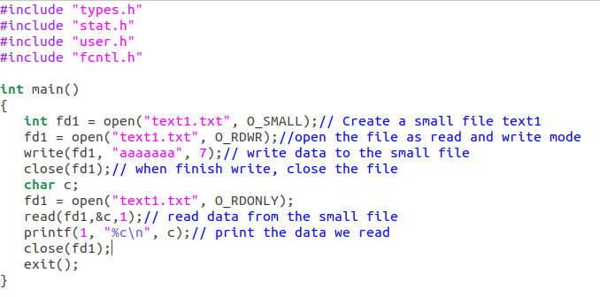

Result:



Create small file success.



Print the data read from small file.

Test2.c:

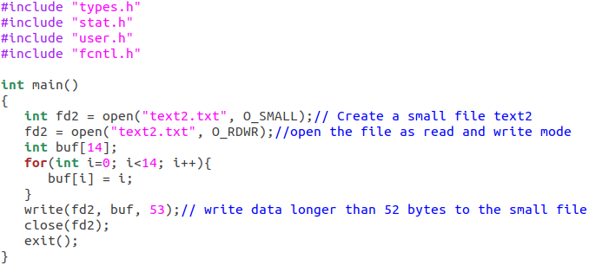

Result:



Write unsuccess.

I think my test cases is good quality because it test both the correct and wrong case when we do read and write for small file.